Session 3 - Work Education - Monday 16th February
- Complete your Resume
- Complete and Upload your Career Action Plan (Learning task)
- If time permits – continue with What is Work activity (Career tools)
Lesson Focus:
- Most students completed their resume late last year, but these may need to be tweaked before applying for Work Experience. As many of you are ready to start applying for casual jobs and also secure work experience placements - please use part of this period to tweak your current Resume and ensure your resume is ready to go (Optional video to watch Resume Revamp)
Sample resume templates: (these are also available on teams)
Resume template 1

Resume template 2
Additionally :
Please remember – we also have Resume samples and tips on resume writing on our school Career Website/ Career Tools. For students who need to revamp their resume, please do this first.
It is recommended that you use the resume template samples (1 or 2 above) but feel free to also check out the resume options on our career school website (snip below)
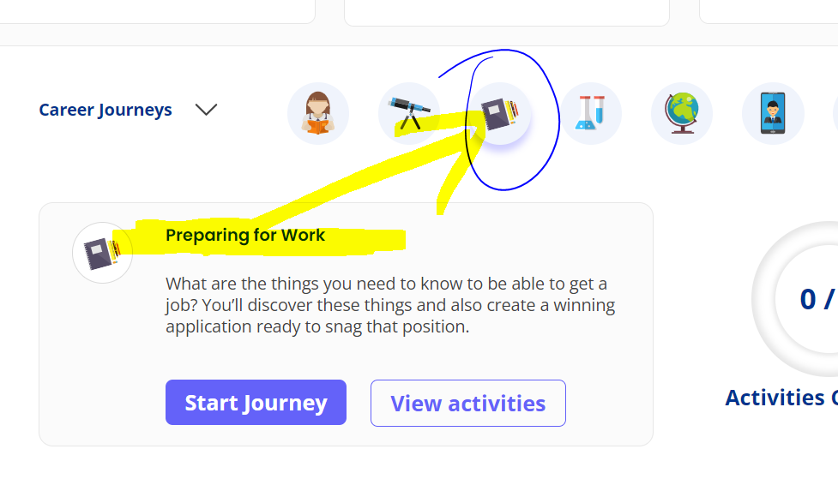

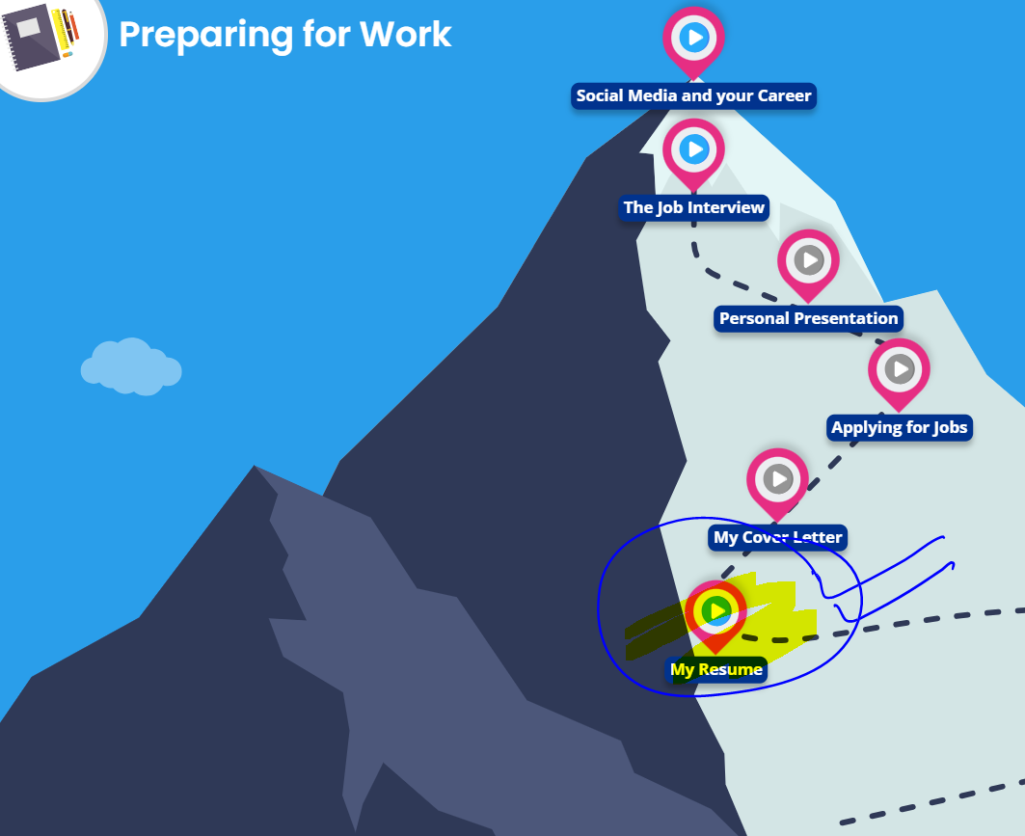
- Once your resume is finalised, please complete your Career Action Plan (learning task) and upload this on compass.

When both Resume and CAPs are completed, you are to continue with the extension activity below:

- What is work?

